AN LAC SEAFOOD CO., LTD. (HK216)
No. 38, 2A Street, Hung Vuong South – Tran Van Kieu North Residential Area, An Lac Ward, Binh Tan District, Hochiminh City, Vietnam.

No.: 08/ALC/ 2011
STATEMENT

TO.: SHING YUEH INTERNATIONAL CO., LTD.

DATE | INVOICE NO. | AWB | TOTAL
07 MAR. | 022/ALC | 695 3339 3846 | 8,673.24
10 MAR. | 023/ALC | 695 3339 3850 | 7,515.70
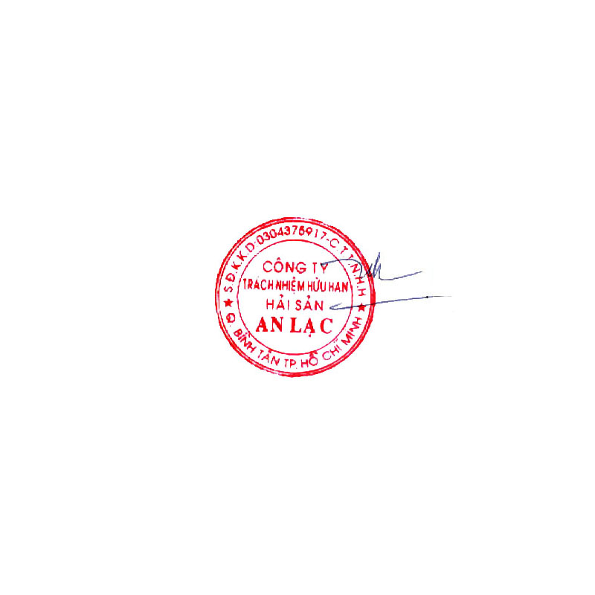  GRAND TOTAL |  |  | USD 16,188.94

Says: US DOLLARS Sixteen Thousand One Hundred Eighty Eight And Ninety-Four Cents Only.
AN LAC SEAFOOD CO., LTD.
Account No. : 1402 1485 100 3419
Name Of Bank : EXIMBANK, DISTRICT 4 BRANCH, HOCHIMINH CITY, VIETNAM.
SWIFT : EBVIVNVXQ04
AN LAC SEAFOOD CO., LTD.

Lê Thị Hoa

